One-Health surveillance for human and animal brucellosis in Kenya: A time series predictive analysis.

Samuel Kahariri1,2,3,4*, Thomas, Lian F.2,5, Bernard Bett2, Marianne Mureithi4, Anita Makori3,6, Brian Njuguna3, Kadivane Samuel7, Dennis N. Makau8, Nyamai Mutono3,6, SM Thumbi3,6,9

1Directorate of Veterinary Services, Nairobi, Kenya

2International Livestock Research Institute, Old Naivasha Road, PO BOX 30709, 00100-Nairobi, Kenya

3Centre for Epidemiological Modelling and Analysis, University of Nairobi, P.O Box 19676-00202, Nairobi, Kenya

4 Department of Medical Microbiology & Immunology, Faculty of Health Sciences, University of Nairobi

5Institute of Infection Veterinary & Ecological Sciences, University of Liverpool, Leahurst Campus, Neston, CH64 7TE, UK

6Paul G. Allen School for Global Health, Washington State University, Pullman, WA, USA

7 Ministry of Health, Kenya.

8 Department of Veterinary Population Medicine, College of Veterinary Medicine, University of Minnesota, Minneapolis, USA

9 Institute of Immunology and Infection Research, University of Edinburgh

*Corresponding Author:

Samuel Kahariri -drkahariri@gmail.com

ORCID 0000-0002-3190-8543

Author Contributions

SK, LFT, BB, MM & SMT conceptualized the work. SK, AM, BN, MN carried out the analysis. SK developed the first draft manuscript. All authors wrote the manuscript, read and approved the final draft of the manuscript.

Abstract

Brucellosis, an endemic bacterial zoonotic disease, poses a significant public health challenge globally. In Kenya, brucellosis is listed as a priority zoonotic disease causing significant morbidity in humans and production losses in livestock. Here we determined the spatial-temporal patterns of human and animal brucellosis in Kenya, and developed prediction models of human brucellosis. We obtained monthly surveillance data on human and animal brucellosis for each of the 47 administrative counties from the official government information systems for human and animal health. The data covered the period 2014 to 2021. We applied Time Series Linear Models to test associations between human and animal brucellosis. We *tested several* seasonal autoregressive integrated moving average (SARIMA) models to identify models with best fit to the data which we used to forecast incidence of human brucellosis for twelve months. Results show that although there was significant association between human brucellosis and combined animal brucellosis, the trend and spatial distribution of human brucellosis does not have a similar pattern with the animal brucellosis as expected. However, the trend and distribution of cattle, goats and sheep brucellosis followed a similar pattern. Our study method and results could provide great insights for improvement of one health surveillance surveillance system and utility of the surveillance data to strengthen Early Warning System through forecasting.

Keywords: Brucellosis, surveillance, zoonotic, time series, and forecast.

Introduction

Brucellosis is a globally widespread zoonotic disease with an estimated annual incidence of 1.6-2.1 million, majority of which are in Africa and Asia (1). In livestock, brucellosis causes large economic losses due to abortions, reduced fertility, and subsequent reduced milk production over an animal’s life span (2). Transmission of brucellosis from animals to humans is primarily through contact with materials from infected animals, and consumption of unpasteurised dairy products (3–5).

In Kenya, brucellosis is listed as one of the top five priority zoonotic disease due to common occurrence, its public health importance, and impact on livestock production (6). Several studies have provided important epidemiological information about brucellosis in Kenya including estimates of incidence in humans (6), variation in the prevalence of human and animal brucellosis across the country (7–10), associations between animal and human brucellosis from linked household studies (7,8,11) and the circulating Brucella species in different livestock hosts (12,13). Based on the current knowledge, Kenya has developed the Brucellosis National Prevention and Control Strategy that emphasizes the need strengthen integrated surveillance, enhance coordination mechanisms and progressively eliminate brucellosis in animals and human (14).

The previous studies are either cross-sectional or short-lived longitudinal studies without any strength as an early warning systems. To the best of our knowledge, none of these studies used data from the routine surveillance information systems and none have attempted to assess the utility of the routine surveillance data to determine the association of human and animal brucellosis and forecast human brucellosis using animal brucellosis incidence in Kenya.

Surveillance data is an indispensable asset for nations to plan, detect case surges, and manage outbreaks effectively. An effective disease surveillance system is essential in enhancing rapid detection of disease outbreaks or health events before transmission within or across species and cause loss of lives (15,16). The key objective of surveillance is to provide data to guide interventions (17). Establishment of a fully Integrated One Health Surveillance System will result in improved prevention, detection and response to disease threats and prevent spillover of most infections to human (16). One Health surveillance should integrate known and unknown pathogens, combined with this traditional disease-based surveillance, and must include surveillance of disease drivers to improve prevention and mitigation of spill-over (16). Scientific analysis and prediction of incidence of human brucellosis cases in humans can benefit of animal and environmental data and assist in decision making for prevention and control measures (18).

Basically the Science of One-Health surveillance systems - what we know about them, and where they have worked or failed.

In this article, we determined the spatial-temporal patterns of the reported cases of brucellosis in the national human and animal surveillance systems, the association between animal and human brucellosis cases, and the short term forecasts of human brucellosis across the country. This work is important for understanding the burden of brucellosis in animals and humans over time across the country, and testing the potential utility of linked animal and human national surveillance systems as early warning system for zoonotic infections as brucellosis.

Methodology

**Data sources.** We obtained data on the human cases of brucellosis from the Kenya Health Information System (KHIS) as monthly aggregates mainly collected from health facilities (19). Data on brucellosis cases in animals (cattle, sheep, goats, and camels) were obtained from the Kenya Animal Biosurveillance System (KABS) (20). The human and animal brucellosis data covered all clinically or laboratory diagnosed cases mainly collected by health and veterinary professional from all 47 counties of Kenya, and covered the period January 2014 to December 2021. We used the 2019 Census data obtained from the Kenya National Bureau of Statistics (KNBS) to estimate human and animal populations (21). The annual human - population estimates for each county were obtained using annual population growth rate estimates from KNBS (21).

**Data analysis:** We computed the monthly incidence rate of human brucellosis for each county using the cases reported during the month and the estimated human population in the county during the same month (assumed to be equivalent to the annual population estimate for the county). The human brucellosis incidence rate was expressed as cases per 1000 population. To estimate brucellosis incidence for each of the selected animal species, we used reported cases for the animal species during the month and estimated their respective population as per the 2019 animal census data. The species specific brucellosis incidence was expressed as cases per 1,000,000 population.

Temporal trends and spatial patterns of brucellosis incidence in humans and the livestock species were presented as time series graphs and choropleth maps.

**Test of association:** This was conducted in 3 stages; individual animal species at national level, combined animal species at national level, combined animal species at individual county level and a fixed effect model for combined animal brucellosis incidence.

To determine the association between brucellosis incidence in humans with incidence in all the animal species and with specific animal species, we fitted Time Series Linear Models at different lags (0 - 3 months), while controlling for trend and seasonality. To account for correlations in data collected from the same geographical areas, we fitted mixed effect models whose parameters were estimated using lme4 package in R. We used county as the random effect to control for the effect of different counties in Kenya. We used Akaike Information Criterion (AIC) to select the lag and model that best fits our data.

The 3 month lag had the lowest AIC as shown on the Table 2 below and was therefore selected as the best fit for our data on individual animal species incidence.

Table 2: Table of AICs for the models at individual and combined species level

|  |  |  |  |  |
| --- | --- | --- | --- | --- |
| Lag in months | Lag 0 | Lag 1 | Lag 2 | Lag 3 |
| Individual animal species (AIC) | *-93.43* | *-102.23* | *-115.97* | *-122.87* |
| Combined animal species (AIC) | *-208.63* | *-206.83* | *-209.88* | *-213.06* |

**Mixed effect model**: Finally mixed-effects modeling approach was employed to investigate the association between human brucellosis incidence and animal brucellosis incidence, while accounting for the hierarchical structure of the data with counties as random effects. After running the models, the results indicated that there was no statistically significant association (p-value >0.05) between human brucellosis incidence and the combined animal brucellosis incidence from the lag of zero month all the way to a lag of three months. Since brucellosis incidence is seen to have seasonal variation, we opted for a model that takes care of seasosonality of the disease.

**SARIMA model:** We use time series analysis when we want to understand the data and predict future points in the series. The Augmented Dickey–Fuller (ADF) unit root test showed that our time series was not stationary, indicating that a long-term trend and seasonal pattern were present. Therefore, we differenced the time series to make it stationary before fitting the model. SARIMA (Seasonal Auto-Regressive Integrated Moving Average) models account for both seasonal patterns and the trend in the data. Sarima has previously been utilized in prediction of brucellosis and other similar diseases (22–24). The ARIMA models deals with non-stationarity such that;

Let be the time series, then if then, .

The general equation for is;

where and .

If the time series is seasonal, in addition to the *p*, *d*, and *q*, we have the seasonal period and , , and are the orders of the seasonal part of the model. Thus, the seasonalgeneral equation is given as;

Where are the polynomials of order and respectively.

The initial SARIMA model solely incorporated human incidence, excluding the covariate, whereas the subsequent SARIMA model integrated animal incidence as the exogenous variable. The stepwise method was employed to identify the optimal model, with selection guided by the Akaike Information Criterion (AIC). The model characterized by the lowest AIC value was selected as the most suitable model for forecasting the human incidence.

A three month lag for combined animal incidence was used because it was statistically significant in predicting the human incidence as an exogenous variable.

**Forecasting:** We split our data into training and testing (80%, 20%) respectively**.** The Root Mean Square Error (RMSE), Mean Absolute Error (MAE), and the Mean Absolute Percentage Error (MAPE) were calculated and used to determine which model performed best in forecasting human incidence in the year 2022. The model with the lowest metrics was chosen as the best fit.

After testing the model we retrained the best model with complete data set 2014 to 2022 and then forecasted for 2023.The Figure 1 below shows a methodological summary of this study.

Figure 1: summary of methodology and approach used to undertake the spatiotemporal analysis and forecast for human brucellosis incidence 2014-2021.

**Statistical software**.

All the analysis was done using R statistical tool (25).

Results

The overall number of cases observed in the eight-year study period was 4,148,208 human cases and 692 animal cases which were from goats 44.2% (n=306), cattle (40.6%, n=281), sheep (11.9%, n=82) and camels (3.3%, n=23).

Sub-nationally, Nakuru County reported the highest number of brucellosis cases in humans, totalling to 7.53% (312,400/4,148,208). Kisii County followed closely with 6.5% (269,499/4,148,208) cases. In contrast, Lamu County had the lowest number of cases at 0.06% (929/4,148,208). Turkana County reported the highest number of brucellosis cases in cattle at 17.4% (49/281), followed by Murang’a County with 9.3% (26/281) cases. Fifteen counties had no cases of brucellosis in cattle, while 32 counties had more than one case of brucellosis in cattle.

In goats, Turkana County had the highest with 37.7% (106/306) brucellosis cases, followed by Mandera County with 18.2% (51/306) cases. Thirty counties had no reported cases of brucellosis in goats, while 17 counties had more than one reported cases of brucellosis in goats. Marsabit county recorded the highest number of sheep cases at 34.2% (28/82), followed by Turkana with 20.7%(17/82) reported cases. Some counties, including Taita Taveta, Siaya, and Nyeri, had no reported cases of sheep. Only four counties -Tana River 56.5%(13/23), Marsabit 34.8%(8/23), Garissa4.4%(1/23) and Isiolo 4.4% (1/23) had cases of brucellosis in camel

Overall, 3,203,162(77.28%) of the reported human cases of brucellosis underwent laboratory diagnosis while in animals only 34.53% (239/692) were laboratory diagnosed. Across the species, most cases were clinically confirmed, except for humans where most cases were lab confirmed as shown in Table 1 below.

## Incidence Rate: The mean incidence rate in humans stood at 1.05 per 1,000, while for the animals, it was 0.17 per 1,000,000 goats, 0.05 per 1,000,000 cattle, 0.02 per 1,000,000 sheep, and 0.04 per 1,000,000 camels as shown in table 1.

The maximum incidence rate in humans was 12 per 1,000, observed in West Pokot County. In goats, the maximum incidence rate was 30 per 1,000,000, reported in Kwale county. For cattle, Mombasa recorded the highest incidence rate of 235 per 1,000,000, while Tana River exhibited the maximum incidence rate for camels at 122 per 1,000,000. Lastly, the maximum incidence rate for sheep was 45 per 1,000,000, observed in Makueni county.

Table 1: Human and animal brucellosis cases, Incidence rates and diagnosis in Kenya 2014-2021.

|  |  |  |  |  |  |
| --- | --- | --- | --- | --- | --- |
| **Parameter** | **Human** | **Cattle** | **Sheep** | **Goat** | **Camel** |
| Total Cases | 4,148,208 (99.98%) | 281 (0.01%) | 82 (<0.01) | 306(0.07%) | 23(< 0.01%) |
| Lab Diagnosis | 3,203,162 (77.28%) | 105 (37.37%) | 17.0(20.73%) | 115 (37.58%) | 2 (8.70%) |
| Clinical Diagnosis | 945,046 (22.78%) | 162(57.65%) | 65(79.27%) | 191(62.42%) | 21 (91.30%) |
| Post-mortem | 0 (0%) | 14 (4.98%) | 0 (0%) | 0 (0%) | 0 (0%) |
| Mean incidence Rate | 1.05 | 0.05 | 0.02 | 0.17 | 0.04 |
| Minimum Incidence | 0.0007 | 0 | 0 | 0 | 0 |
| Maximum Incidence | 12 | 235 | 45 | 30 | 122 |
| Median Incidence | 0.66 | 0 | 0 | 0 | 0 |
| Standard Deviation of the Incidence | 1.12 | 2.42 | 0.69 | 3.94 | 0.69 |

The average brucellosis incidence in human maintained a gradual increase from around October 2014 and peaked in July 2017. From there the average incidence experienced uneven surges and the greatest peak was experienced in August 2019 as shown in the figure 2. In animals, cattle and goat incidences was seen to follow a fairly similar pattern with highest incidence being in cattle. Cases of brucellosis in camel seems to have been reported sporadically around 2015, 2019 and 2020. From the trends in the figure below, the trend in the animal brucellosis are distinctly different from the trend of the human brucellosis incidence.

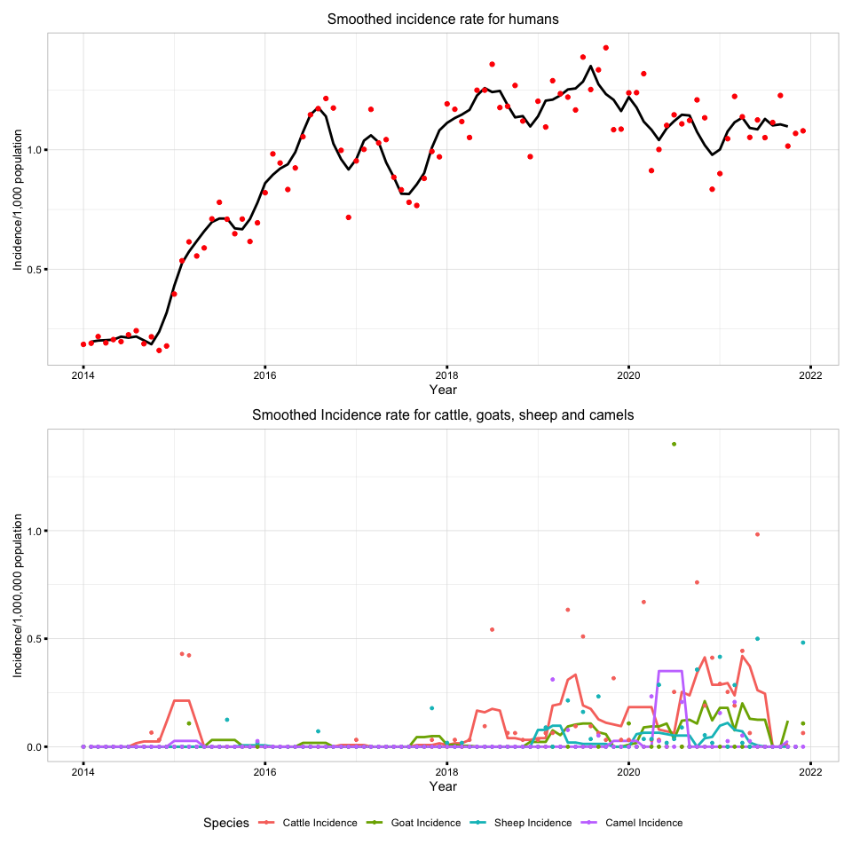

Figure 2: monthly distribution of humans and animal brucellosis average incidences incidences in Kenya, 2014-2021

Human incidence was higher than the the animal incidences with cases distributed across the all counties as showm in the Figure 3. The Coastal counties have consistently reported the lowest incidences of human and animal brucellosis. On the contrary, some cases were reported in 2015 in goats in Kilifi and 2018 in cattle. A big number of counties had no reported cases in animals despite having significant human incidence.

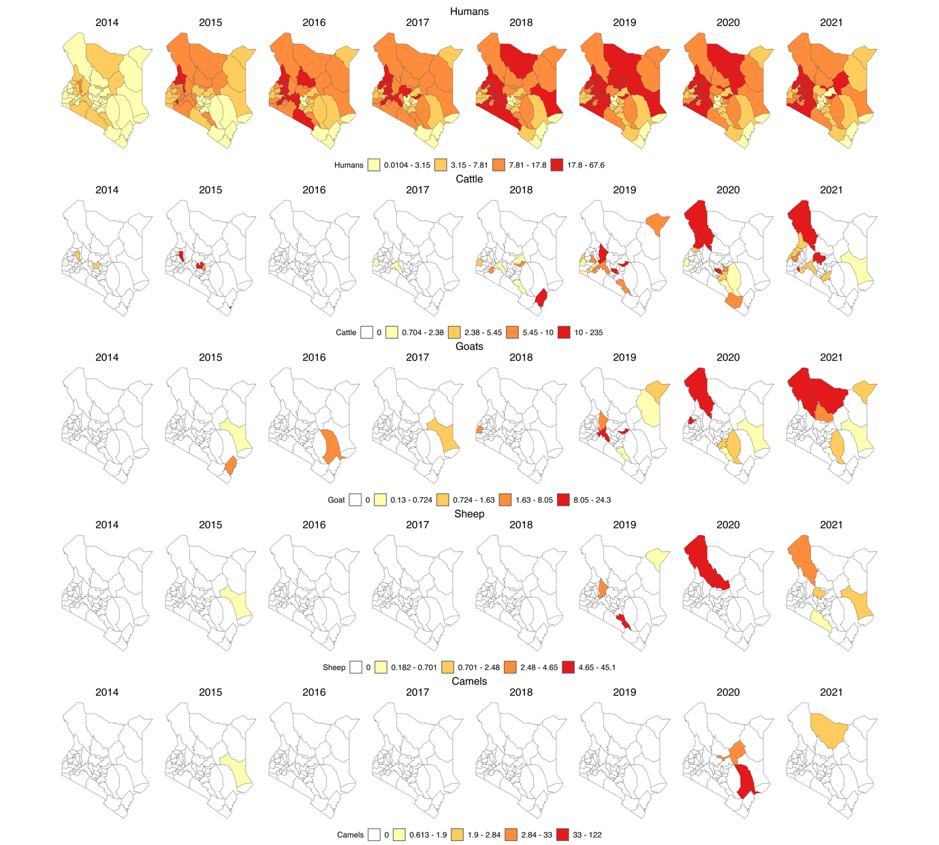

Figure 3: yearly incidence of human and animal Brucellosis at the county level in Kenya, 2014–2021. (For humans the incidence rate is per 1,000 population while for animal species it is per 1,000,000 population, and the colour is per the percentiles).

**Individual animal species at national level:** Three of the four animal species brucellosis incidence showed no statistically significant association with human brucellosis incidence (Estimates; camel=0.128 (-0.267 to 0.523), sheep = 0.830 (-0.303 to 1.963), goat = 0.535(-0.414 to 0.917)) and their wide confidence intervals which include zero indicated uncertainity about the true effect they have on human brucellosis incidence. However, at 95% confidence interval cattle brucellosis incidence was marginally significantly associated (with human brucellosis incidence with an estimate of 0.355 (0.004 to 0.707). Details are shown in the Table 3 below.

Table 3: Results for test of association between human brucellosis and individual animal species brucellosis at lag3

| variable | estimate | std.error | statistic | p.value | conf_low | conf_high |
| --- | --- | --- | --- | --- | --- | --- |
| (Intercept) | 0.867 | 0.039 | 22.245 | 0.000 | 0.803 | 0.931 |
| Camel incidence | 0.128 | 0.240 | 0.534 | 0.595 | -0.267 | 0.523 |
| Sheep incidence | 0.830 | 0.689 | 1.205 | 0.231 | -0.303 | 1.963 |
| Cattle incidence | 0.355 | 0.214 | 1.661 | 0.100 | 0.004 | 0.707 |
| Goat Incidence | 0.252 | 0.404 | 0.622 | 0.535 | -0.414 | 0.917 |

**Combined species at national level:** The models were fitted at the three lags and evaluated using the AICs. The model with the lowest AIC was at lag 3 as shown on Table 2 above.

According to the model, the combined animal brucellosis incidence is a statistically significant (*p*-value = 0.008) predictor of human brucellosis incidence at 95% confidence interval. As suggested by the AIC, the model, is a good fit. The summary of the model output is shown in the table below.

Table 4: Results for test of association between human brucellosis incidence and log 3 of animal brucellosis incidence

|  |  |  |  |  |  |  |
| --- | --- | --- | --- | --- | --- | --- |
| Variable | Estimate | Std.error | Statistic | P.value | Conf_low | Conf_high |
| (intercept) | 0.900 | 0.036 | 24.711 | 0.000 | 0.840 | 0.960 |
| Animal incidence | 1.115 | 0.408 | 2.732 | 0.008 | 0.444 | 1.787 |

**Individual county**: We proceeded further, to test the association between combined animal brucellosis incidence and human brucellosis incidence at 3 months lag for each individual county and they were all not significantly associated (p-value > 0.05).

**SARIMA prediction analysis:** In the initial SARIMA model, was identified as the optimal model, while in the subsequent SARIMA model incorporating a covariate, was determined to be the best-fitting model. The d = 1 implies that the time series was differenced at lag 1 for it to be stationary.

We used each of the above models to forecast the human incidence in the year 2022 and then calculated the RMSE, MAE and MAPE for each. In the initial SARIMA model, the Root Mean Square Error (RMSE) was 0.231, the Mean Absolute Error (MAE) was 0.215, and the Mean Absolute Percentage Error (MAPE) was 25.139. Subsequently, in the SARIMA model incorporating the covariate, these metrics changed to an RMSE of 0.231, MAE of 0.207, and MAPE of 24.391. Based on these performance metrics, we concluded that the model utilizing animal incidence as the exogenous variable provided the most accurate forecastof human brucellosis incidence in the year 2022.

Table 5: Error metrics used to select the best fit model

|  |  |  |  |
| --- | --- | --- | --- |
| Model | RMSE | MAE | MAPE |
| Model without exogenous variable | 0.231 | 0.215 | 25.139 |
| Model with exogenous variable | 0.231 | 0.207 | 24.391 |

We further plotted figure 4 in order to visualize the training and testing for the 2 forecast models. As shown in the figures below, most of our predicted values were within the 95% prediction interval and the forecast with exogenous variable was closer to the actual human incidence.

The first plot on the top shows the training and testing forecasting of human incidence based on the first SARIMA model without the exogenous variable. The second plot in the bottom shows the training and testing forecasting of human incidence based on the second SARIMA model with the exogenous variable.



Figure 4: training and testing models for prediction of human Brucellosis in Kenya, from January 2022 to December 2022. (For humans the incidence rate is per 1,000 population).

After establishing that the forecasting model with animal incidence fitted our data better than without the exogenous variable, we retrained the best model with complete data set 2014 to 2022 and then forecasted for 2023 as shown in the figure below.

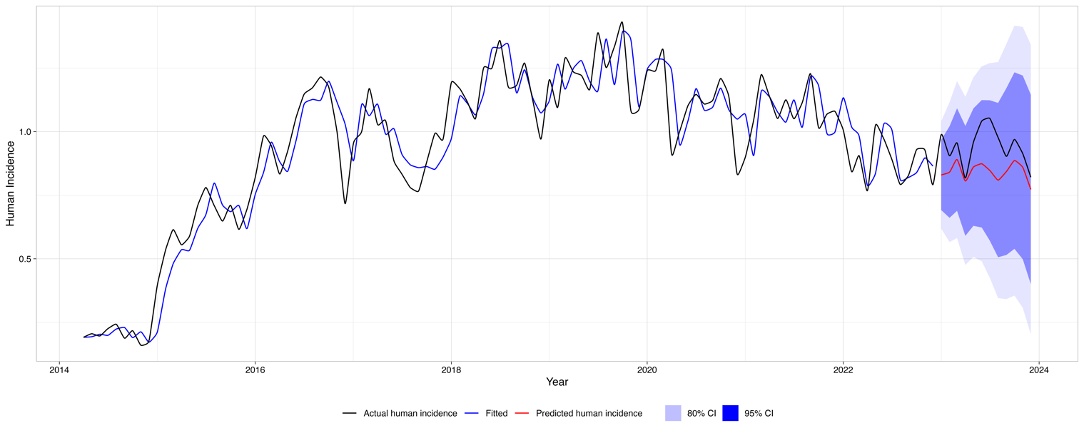

Figure 5: Prediction of human incidence of brucellosis in Kenya, from January to December 2023. (For humans the incidence rate is per 1,000 population).

Discussion

From this study, we observe major structural differences in the human and animal surveillance systems, some of which contribute to the observed underreporting of health events.

In Kenya, the human health surveillance system utilizes laboratory diagnosis much more compared to the animal surveillance system. This is most likely due to the structural differences between the two surveillance systems. In the human health surveillance system, the health facilities have varying capacities for brucellosis diagnosis ranging from basic to complex tests. Animal health surveillance mainly relies on the sparsely distributed Regional Veterinary Investigative Laboratories (RVILs) for laboratory confirmation of cases. To submit samples, veterinary practitioners could in some cases incur some expenses and this discourages sample collection. This could explain why most of the reports from the animal health sector are based on clinical diagnosis. The clinical picture of brucellosis can be confusing because unusual cases with uncharacteristic lesions continue to be reported. For this reason, diagnosis ought to be supported by laboratory tests (26). The quality of the data in animal health surveillance system is therefore, greatly affected by the conspicuously high level of underreporting and minimal utilization of the laboratory diagnostic services as evidenced by the study. This could compromise the utility of animal incidences of brucellosis to predict human brucellosis.

Brucellosis diagnosis has been identified as one of the major hindrances to the eradication of the disease (27) since it can be clinically confused with various other conditions in both humans and animals. In our surveillance systems, there was a significant number of reports that were diagnosed clinically, especially in animal health surveillance. In Kenya, studies have confirmed lack of reliable diagnostic support, use of highly sensitive tests and routine disease underreporting greatly affect the surveillance systems and potentially cause false alerts (5).

Postmortem diagnosis may not be very key in the diagnosis of brucellosis although coupled with the culture it has been seen to be important when pursuing a definitive diagnosis of brucellosis (27). From this study, the analysis reveals that the official human health surveillance system lacks mechanisms for capturing cases that may be picked during the pathological examination at the postmortem. This could lead to the loss of some important information and underreporting of human health events.

Generally, the spatial distribution and the numbers of cases (reports) captured in the human health surveillance system are comparatively much more than those captured in the animal health surveillance system. Additionally, the distribution of the animal cases does not necessarily follow the same pattern as the cases of human probably due to poor data quality. This is contrary to previous studies that proved existence of similar distribution pattern and trends in human and animal brucellosis (28–30) and this is probably due to underreporting, misdiagnosis, and other factors weakening the surveillance systems. A case in point for Isiolo county which previous studies have identified as brucellosis endemic county (30), but have not recorded any cases in animals during the study period is a good evidence of weaknesses in surveillance system that arise from inadequate reporting of health events (31). Cattle and goat incidences follow a fairly similar distribution patterns and like in previous studies, cattle cases were higher than the sheep and goat cases(28).

In the human health surveillance system, the reports are aggregated at the health facilities that are spread all over the country. On the contrary, in the animal health surveillance system, the reports are collected at the herd/farm level from villages, laboratories, clinics, crushes, and abattoirs. The vast distribution of health facilities in Kenya could also contribute to the observed higher spatial distribution and numbers of reports observed in the human population. The bulk of the cases in the animal health surveillance system were in cattle since cattle are the most widely distributed animal species in Kenya (KNBS, 2019).

The distribution of brucellosis cases in the country as manifested by the study is affected by reporting bias across counties and thus the need to ensure that both surveillance systems have a clearly established zero reporting for all the priority zoonotic diseases to remove uncertainity and distinguish absence of disease (32) from lack of reporting.

Previous studies established that in developing countries, *B. abortus*, *B. melitensis,* and *B. suis* are leading causes of animal and human brucellosis (7,26) and that there is a high correlation between human brucellosis and brucella seroprevalence in animals (6,33,34). However, this study found discrepancies in the association that could be explained by inadequacy and weaknesses in the Kenyan surveillance system and data. Forecast model fitted the data better when brucellosis incidences are forecasted with the animal brucellosis incidences, which further underscores the need to address the weaknesses in our surveillance systems. Poor quality data could arise from challenges affecting the surveillance systems. Some of the key challenges affecting the surveillance systems identified in the previous studies include; vastness and remoteness of some areas characterized by poor infrastructure and communications, the need to conduct adequate surveillance with limited financial resources (35), inadequate numbers of trained personnel (36), lack of supplies, materials, transport facilities, diagnostic facilities (37–39), “Commercial interest” (40), unharmonized reporting structures, inadequate response to disease outbreaks, lack of incentives and motivation for surveillance and political interference (41) among others.

In order to control the priority zoonotic diseases our study agrees with previous studies on the need to address the disease in the animal reservoirs and strengthen its surveillance and management in animals to reduce the incidence in human populations through a One Health framework Hull and Schumaker, 2018). Effective control measure would benefit from a targeted intervention policy and strengthened cooperation between human health and veterinary services (24,29).

This study had several limitations. Firstly, the use of data that included clinically diagnosed cases of brucellosis. Secondly, the use of retrospective data extracted from routine surveillance systems could be affected by reporting bias. However, for the purpose of this work, since the focus here was the surveillance system and identifying the shortfalls, the information in the official surveillance systems was extracted, collated, cleaned, and analyzed in its original state.

Conclusion

This study is the first prediction of human brucellosis in Kenya for the period 2014 to 2021. Our study confirmed that SARIMA is effective in forecasting the human incidence of brucellosis using the reported cases in the routine animal and human surveillance systems. SARIMA outperforms ETS and ARIMA in the forecasting accuracy. Using the established model, we tested accuracy of human brucellosis incidence prediction in Kenya from 2022 to 2023. Our study method and prediction results can contribute great ideas to policy makers for improvement of human and animal diseases surveillance system and utility of the surveillance data to strengthen Early Warning System.

Animal health surveillance data is important in informing the human health surveillance system and therefore be useful in forecasting public health events. However, the current surveillance systems may not be projecting the accurate disease situation since they have both structural and operational issues that should be addressed to improve the quality of information collected and consequently their potential to inform the Early Warning systems for zoonoses in Kenya.

There is a need to establish and strengthen an integrated surveillance system in Kenya. This may be established outside any legal framework, and its success relies on the identification of synergies across components that could be brought together more effectively (42).

Acknowledgments

SK, BB & LFT are supported by the BMZ funded ‘One Health Centre for Research, Education & Outreach (OHRECA). LFT is also supported by the Welcome Trust-University of Liverpool Institutional Strategic Support Fund and is a Soulsby Foundation One Health Travelling Fellow. The funders had no role in the decision to publish or the preparation of this manuscript.

Data Availability

The data used in this study and the analysis code will be made available on request to the corresponding author.

Conflict of interests

The authors declare no conflict of interest

References

1. Laine CG, Johnson VE, Scott HM, Arenas-Gamboa AM. Global Estimate of Human Brucellosis Incidence - Volume 29, Number 9—September 2023 - Emerging Infectious Diseases journal - CDC. Emerg Infect Dis [Internet]. 2023 Sep 1 [cited 2024 Feb 26];29(9):1789–97. Available from: https://wwwnc.cdc.gov/eid/article/29/9/23-0052_article

2. McDermott J, Grace D, Zinsstag J. Economics of brucellosis impact and control in low-income countries. Rev Sci Tech [Internet]. 2013 [cited 2024 Feb 26];32(1):249–61. Available from: https://pubmed.ncbi.nlm.nih.gov/23837382/

3. Nasinyama G, Ssekawojwa E, Opuda J, Grimaud P, Etter E, Bellinguez A. Brucella sero-prevalence and modifiable risk factors among predisposed cattle keepers and consumers of un-pasteurized milk in Mbarara and Kampala districts, Uganda. Afr Health Sci. 2014;14(4):790–6.

4. Nejad RB, Krecek RC, Khalaf OH, Hailat N, Arenas-Gamboa AM. Brucellosis in the middle east: Current situation and a pathway forward. Vol. 14, PLoS Neglected Tropical Diseases. 2020.

5. Njeru J, Wareth G, Melzer F, Henning K, Pletz MW, Heller R, et al. Systematic review of brucellosis in Kenya: Disease frequency in humans and animals and risk factors for human infection. Vol. 16, BMC Public Health. BioMed Central Ltd.; 2016.

6. Munyua P, Osoro E, Hunsperger E, Ngere I, Muturi M, Mwatondo A, et al. High incidence of human brucellosis in a rural pastoralist community in Kenya, 2015. PLoS Negl Trop Dis. 2021 Feb 1;15(2).

7. Osoro EM, Munyua P, Omulo S, Ogola E, Ade F, Mbatha P, et al. Strong association between human and animal brucella seropositivity in a linked study in Kenya, 2012-2013. American Journal of Tropical Medicine and Hygiene. 2015 Aug 1;93(2):224–31.

8. Muema J, Oboge H, Mutono N, Makori A, Oyugi J, Bukania Z, et al. Sero – epidemiology of brucellosis in people and their livestock: A linked human – animal cross-sectional study in a pastoralist community in Kenya. Front Vet Sci. 2022;9.

9. Akoko JM, Mwatondo A, Muturi M, Wambua L, Abkallo HM, Nyamota R, et al. Mapping brucellosis risk in Kenya and its implications for control strategies in sub-Saharan Africa. Scientific Reports | [Internet]. 123AD;13:20192. Available from: https://doi.org/10.1038/s41598-023-47628-1

10. Lokamar PN, Kutwah MA, Munde EO, Oloo D, Atieli H, Gumo S, et al. Prevalence of brucellosis in livestock keepers and domestic ruminants in Baringo County, Kenya. PLOS global public health [Internet]. 2022 Aug 15 [cited 2024 Feb 26];2(8):e0000682. Available from: https://pubmed.ncbi.nlm.nih.gov/36962768/

11. Mwatondo A, Muturi M, Akoko J, Nyamota R, Nthiwa D, Maina J, et al. Seroprevalence and related risk factors of Brucella spp. in livestock and humans in Garbatula subcounty, Isiolo county, Kenya. PLoS Negl Trop Dis [Internet]. 2023 Oct 1 [cited 2024 Feb 26];17(10). Available from: https://pubmed.ncbi.nlm.nih.gov/37844102/

12. Akoko JM, Pelle R, Lukambagire AHS, Machuka EM, Nthiwa D, Mathew C, et al. Molecular epidemiology of Brucella species in mixed livestock-human ecosystems in Kenya. Sci Rep. 2021 Dec 1;11(1).

13. Akoko J, Pelle R, Kivali V, Schelling E, Shirima G, MacHuka EM, et al. Serological and molecular evidence of Brucella species in the rapidly growing pig sector in Kenya. BMC Vet Res [Internet]. 2020 May 11 [cited 2024 Feb 26];16(1). Available from: https://pubmed.ncbi.nlm.nih.gov/32393374/

14. Zoonotic Disease Unit K. Kenya brucellosis control strategy. Government of Kenya; 2022.

15. Surveillance in emergencies [Internet]. [cited 2024 Feb 27]. Available from: https://www.who.int/emergencies/surveillance

16. Hayman DTS, Adisasmito WB, Almuhairi S, Behravesh CB, Bilivogui P, Bukachi SA, et al. Developing One Health surveillance systems. One Health. 2023 Dec 1;17:100617.

17. Nsubuga P, White ME, Thacker SB, Anderson MA, Blount SB, Broome C V., et al. Public Health Surveillance: A Tool for Targeting and Monitoring Interventions. Disease Control Priorities in Developing Countries [Internet]. 2006 [cited 2024 Feb 27]; Available from: https://www.ncbi.nlm.nih.gov/books/NBK11770/

18. Huppert A, Katriel G. Mathematical modelling and prediction in infectious disease epidemiology. Vol. 19, Clinical Microbiology and Infection. Blackwell Publishing Ltd; 2013. p. 999–1005.

19. Cunningham Paul, Cunningham Miriam. IST-Africa 2012 conference proceedings and exhibition 9-12 May 2012, Dar es Salaam, Tanzania. IIMC; 2012.

20. Njenga K, Kemunto N, Kahariri S, Holmstrom L, Oyas H, Biggers K, et al. High Real-time Reporting of Domestic and Wild Animal Diseases Following Rollout of Mobile Phone Reporting System in Kenya. 2020;

21. KNBS 2019. 2019 Kenya Population and Housing Census. 2019.

22. Mao Q, Zhang K, Yan W, Cheng C. Forecasting the incidence of tuberculosis in China using the seasonal auto-regressive integrated moving average (SARIMA) model. J Infect Public Health. 2018 Sep 1;11(5):707–12.

23. Akermi SE, L’hadj M, Selmane S. Epidemiology and Time Series Analysis of Human Brucellosis in Tebessa Province, Algeria, from 2000 to 2020. J Res Health Sci [Internet]. 2022 Dec 1 [cited 2024 Feb 14];22(1):e00544. Available from: /pmc/articles/PMC9315461/

24. Zheng Y, Zhang L, Wang C, Wang K, Guo G, Zhang X, et al. Predictive analysis of the number of human brucellosis cases in Xinjiang, China. Sci Rep. 2021 Dec 1;11(1).

25. Team RC. R: A language and environment for statistical computing. R Foundation for Statistical Computing, Vienna, Austria. http://wwwR-project.org/ [Internet]. 2016 [cited 2023 May 27]; Available from: https://cir.nii.ac.jp/crid/1574231874043578752.bib?lang=en

26. Corbel M. Brucellosis: an Overview. Emerg Infect Dis [Internet]. 1997 Jun;3(2):213–21. Available from: http://www.cdc.gov/ncidod/eid/vol3no2/corbel.htm

27. Hull NC, Schumaker BA. Comparisons of brucellosis between human and veterinary medicine. Vol. 8, Infection Ecology and Epidemiology. Taylor and Francis Ltd.; 2018.

28. Zhou K, Wu B, Pan H, Paudyal N, Jiang J, Zhang L, et al. ONE Health Approach to Address Zoonotic Brucellosis: A Spatiotemporal Associations Study Between Animals and Humans. Front Vet Sci [Internet]. 2020 Sep 2 [cited 2024 Feb 9];7:521. Available from: /pmc/articles/PMC7492289/

29. De Massis F, Di Girolamo A, Petrini A, Pizzigallo E, Giovannini A. Correlation between animal and human brucellosis in Italy during the period 1997–2002. Clinical Microbiology and Infection. 2005 Aug 1;11(8):632–6.

30. Njeru J, Nthiwa D, Akoko J, Oyas H, Bett B. Incidence of Brucella infection in various livestock species raised under the pastoral production system in Isiolo County, Kenya. BMC Vet Res [Internet]. 2021 Dec 1 [cited 2024 Feb 9];17(1):1–12. Available from: https://bmcvetres.biomedcentral.com/articles/10.1186/s12917-021-03036-z

31. Armstrong G, Birkhead GS, Horan JM, Herrera G, Lee LM, Milstein RL, et al. Updated Guidelines for Evaluating Public Health Surveillance Systems Recommendations from the Guidelines Working Group The following CDC staff members prepared this report. 2001.

32. Chow A, Leo YS. Surveillance of Disease: Overview. International Encyclopedia of Public Health [Internet]. 2017 Oct 6 [cited 2024 Feb 12];124. Available from: /pmc/articles/PMC7149774/

33. Reif JS. Animal sentinels for environmental and public health. Public Health Rep [Internet]. 2011;126 Suppl 1(SUPPL. 1):50–7. Available from: http://www.ncbi.nlm.nih.gov/pubmed/21563712

34. Pearce N, Douwes J. Research at the interface between human and veterinary health. Prev Vet Med [Internet]. 2013 Sep 1;111(3–4):187–93. Available from: http://www.ncbi.nlm.nih.gov/pubmed/23791125

35. Allport R, Mosha R, Bahari M, Swai E, Catley A. The use of community-based animal health workers to strengthen disease surveillance systems in Tanzania. 2005;24(3):921–32.

36. Halliday J, Daborn C, Auty H, Mtema Z, Lembo T, Bronsvoort BM deC., et al. Bringing together emerging and endemic zoonoses surveillance: shared challenges and a common solution. Philosophical Transactions of the Royal Society B: Biological Sciences [Internet]. 2012 Oct 19;367(1604):2872–80. Available from: https://royalsocietypublishing.org/doi/10.1098/rstb.2011.0362

37. Robertson C, Sawford K, Daniel SLA, Nelson TA, Stephen C. Mobile phone-based infectious disease surveillance system, Sri Lanka. Emerg Infect Dis [Internet]. 2010 Oct;16(10):1524–31. Available from: http://www.ncbi.nlm.nih.gov/pubmed/20875276

38. Omondi M, Ngere I, Ndeta C. Report on the Evaluation of Surveillance Systems Relevant to Zoonotic Diseases in Kenya-2015: A Basis for Design of an Integrated Human Livestock Surveillance System Evaluation Report [Internet]. 2016. Available from: www.zoonotic-diseases.org

39. Don Bamunusinghage Nihal P, Dangolla A, Hettiarachchi R, Abeynayake P, Stephen C. CHALLENGES AND OPPORTUNITIES FOR WILDLIFE DISEASE SURVEILLANCE IN SRI LANKA. J Wildl Dis [Internet]. 2020 Jul 2;56(3):538. Available from: https://bioone.org/journals/journal-of-wildlife-diseases/volume-56/issue-3/2019-07-181/CHALLENGES-AND-OPPORTUNITIES-FOR-WILDLIFE-DISEASE-SURVEILLANCE-IN-SRI-LANKA/10.7589/2019-07-181.full

40. Johnson I, Hansen A, Bi P. The challenges of implementing an integrated One Health surveillance system in Australia. Zoonoses Public Health [Internet]. 2018 Feb;65(1):e229–36. Available from: http://doi.wiley.com/10.1111/zph.12433

41. Omondi M, Ngere I, Ndeta C. Report on the Evaluation of Surveillance Systems Relevant to Zoonotic Diseases in Kenya-2015: A Basis for Design of an Integrated Human Livestock Surveillance System Evaluation Report [Internet]. 2016. Available from: www.zoonotic-diseases.org

42. Bordier M, Delavenne C, Nguyen DTT, Goutard FL, Hendrikx P. One Health Surveillance: A Matrix to Evaluate Multisectoral Collaboration. Front Vet Sci [Internet]. 2019 Apr 24;6(April):1–12. Available from: https://www.frontiersin.org/article/10.3389/fvets.2019.00109/full